**BDA LAB - Student Database**

**Perform the following DB operations using MongoDB.**

1. Create a database “Student” with the following attributes Rollno, Age, ContactNo, Email-Id.

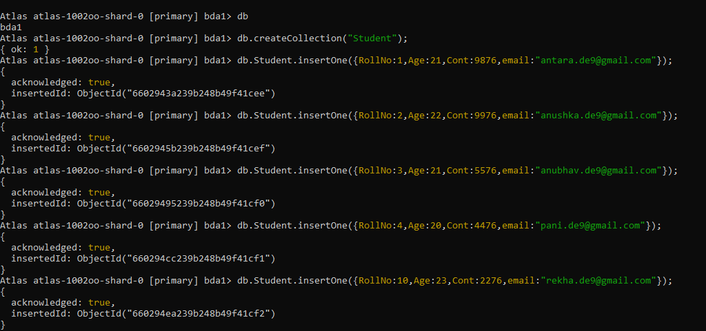

2. Insert appropriate values

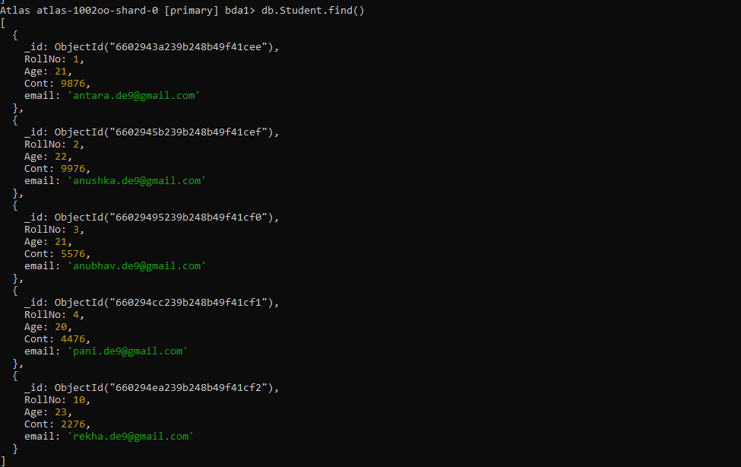

3. Write a query to update Email-Id of a student with rollno 10.

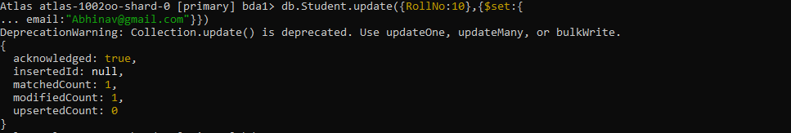

4. . Replace the student name from “ABC” to “FEM” of rollno 11

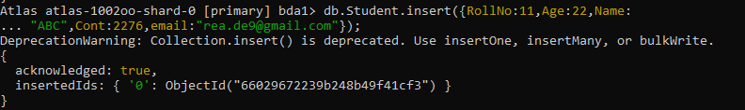

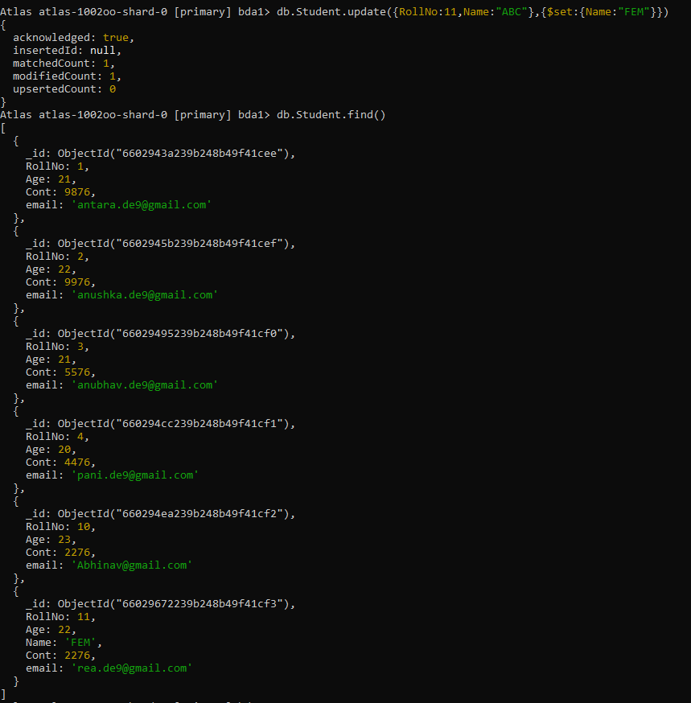

5. Display Student Name and grade(Add if grade is not present)where the _id column is 1.

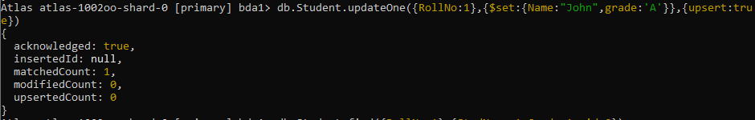



6. Update to add hobbies

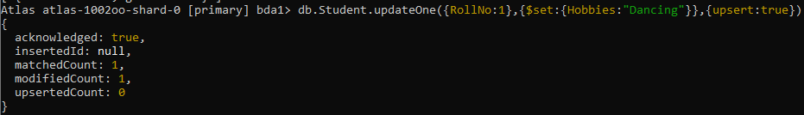

7. Find documents where hobbies is set neither to Chess nor to Skating

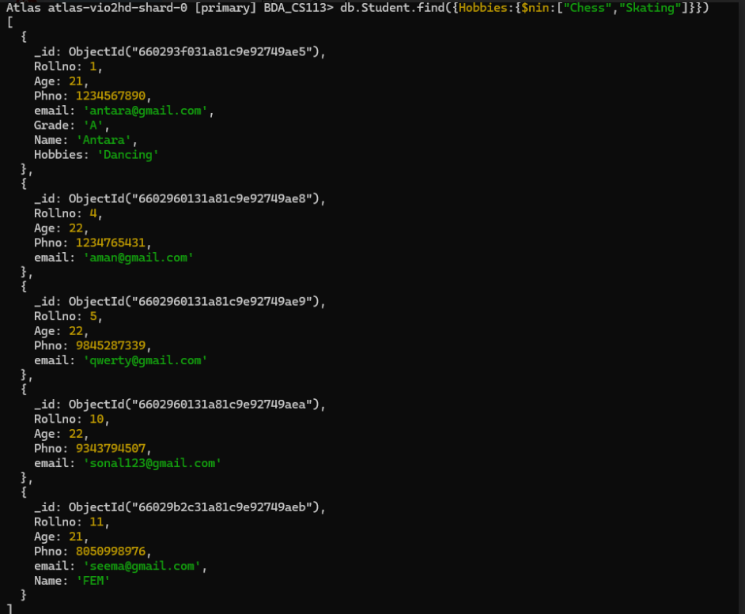

8.Find documents whose name begins with A

